* Checking the main page display

1. Verifying main page display properly.
2. Verifying all products, navigation bar, delivery area display properly.
3. Products can be added to cart.

* Checking the signup and Login functionality

1. Make sure the signup page displays properly.
2. Enter initial customer information and set the username and password.
3. Submit.
4. Back to main page
5. Click login and login to account. successfully.
6. Verifying all information displayed in customer center displays properly.
7. Sign out successfully.

* Checking the admin functionality

1. Make sure the signup page displays properly.
2. Login to admin account
3. Successfully view the detail of item catalog, customer accounts, etc...

* Checking the cart functionality

1. Verifying main page display properly.
2. Add any products to the cart, and click place the order.
3. Verifying did the page transfer to the order page.
4. Making sure the order details display properly.
5. Click place the order successfully.

* Validate updates to item catalog Yes
* Purchasing things successfully No (Because the payment functionality is not one goal in our play and still not implemented yet. )
* Entering in invalid amounts Yes
* Improper password Yes
* Adding, Deleting item catalog in backend (by admin account) Yes

We invited 8 subjects to take the usability test and finished three tasks which mainly experience the main functionalities of our website. We recorded the time and the errors they made during every task. All unintentional click or mis click may be accounted as errors.

Task 1: Please Signup and login successfully

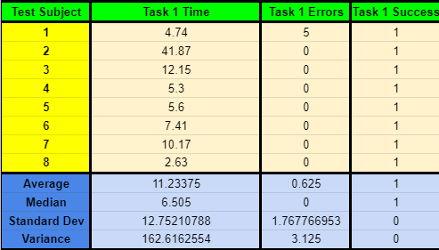

Task 2: Please login by the admin account successfully and delete one category.

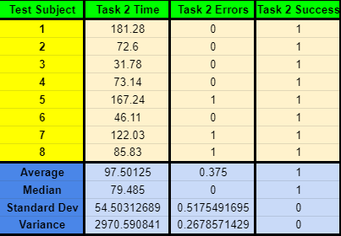

Task 3: Add one product to cart and place the order

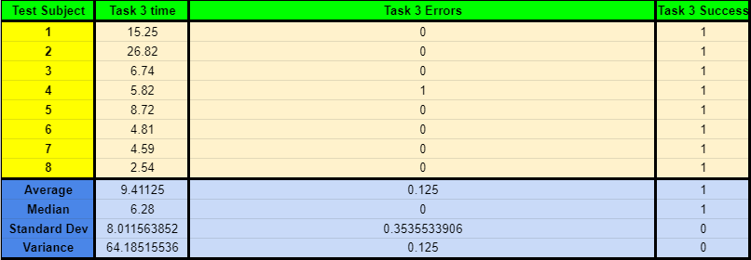

Results:

In general, All subjects all successfully finished the tasks and successfully experienced the functionalities of the website.